Project Development Phase
Model Performance Test

Date | 7 march 2026
Team ID
Project Name | Visualization Tool for Electric Vehicle Charge and Range Analysis
Maximum Marks

Model Performance Testing:

S.No. | Parameter | Screenshot / Values
1. | Data Rendered | 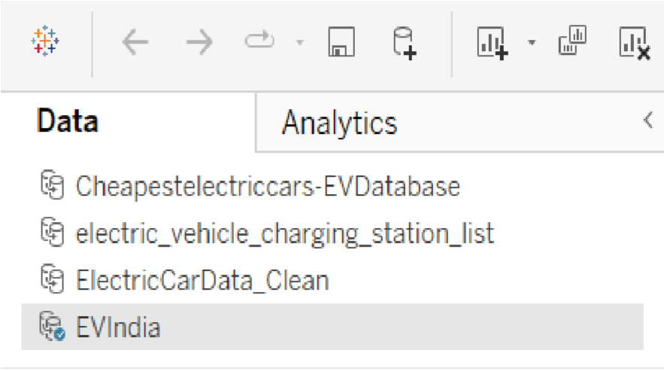
2. | Data Preprocessing | Null handling, calculated fields created for price, range, boot space. Parsed strings to numeric values.
3. | Utilization of Filters | Brand, Segment, Vehicle Type, Region, Transmission, PowerTrain. Used across dashboards for interactivity.  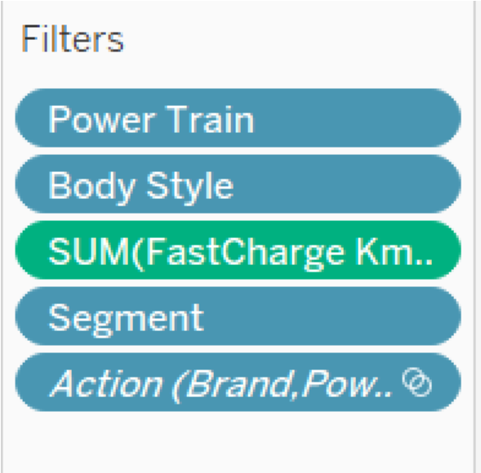
4. | Calculation fields Used | CleanRange_Km_India, CleanBootSpace, Brand(India), ₹ per Km, CleanPriceGermany, etc.  
5. | Dashboard design | No of Visualizations / Graphs - 10 Sheets + 2 Dashboard  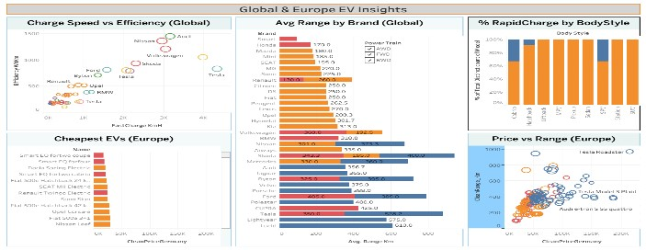  Dashboard  -  1:  Global  Dashboard-2: India  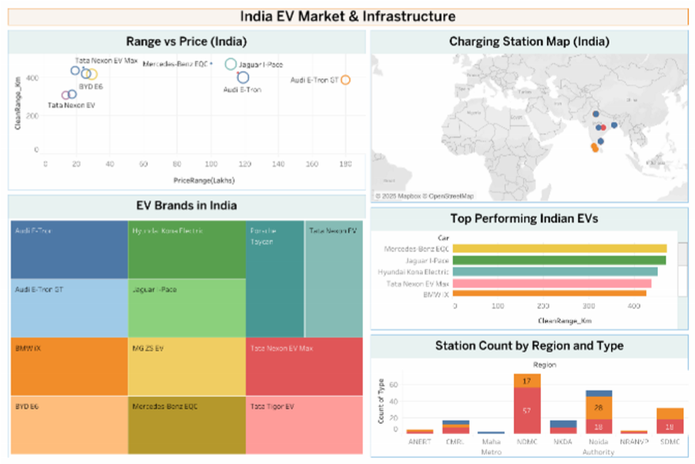
6 | Story Design | Top Performing EVs in India  